The
Global Citizenship
and
Multilingual Competences
Toolkit

Teaching module

Disclaimer: The European Commission support for the production of this publication does not constitute an endorsement of the contents which reflects the views only of the authors, and the Commission cannot be held responsible for any use which may be made of the information contained therein.​

Unit 2:
Promoting Ecoliteracy

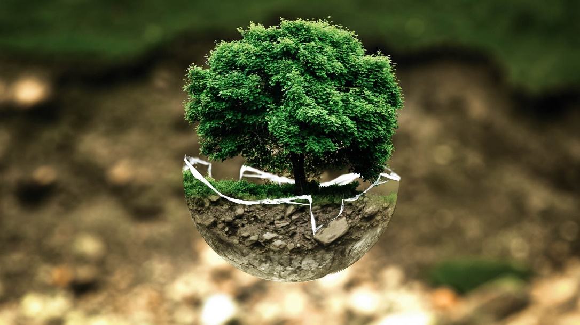

Teaching Module

Table of contents
Activity 1: Warm up p. 5
Activity 2: Climate crisis p. 7
Activity 3: Biodiversity loss p. 13
Activity 4: Pollution and waste management p. 15
Activity 5: Overconsumption p. 18
Activity 6: Sustainability p. 21
Unit 2: Focus on teaching

Promoting ecoliteracy

Introduction

This unit addresses the following themes related to the environment: climate crisis, biodiversity loss, pollution and waste management, overconsumption, and sustainability. It is important for students to study and engage with these topics in order to broaden their understanding of “Ecoliteracy”, namely the personal and social power that comes from being aware of how natural systems work. The materials and exercises have been specifically designed for learners in secondary education (ages 13-18). The activities intend to raise students’ awareness of environmental issues, and to encourage them to take action by adopting sustainable practices and habits in their everyday life, both at school and at home. The exercises are aimed at prompting learners to reflect on the fact that small changes and actions made by each of us can make a big difference to the planet and to all the creatures living on it.

Learning objectives and outcomes

Learning objectives  This unit aims to: | Learning outcomes  At the end of the unit, your students can:
1. [Value, n. 4]: Raise your students’ awareness of topics related to environmental sustainability  2. [Attitude, n. 10]: Encourage your students to be responsible global citizens.  3. [Skills, n. 5]: Foster students’ awareness that their choices or lack of action affect their own lives and those of others.  4. [Knowledge, n. 6]: Raise your students’ awareness of how their consumption habits have an effect on people and the environment in other parts of the world. | 1. [Value, n. 3 and 4]: Feel a deeper sense of responsibility for taking action on environmental issues which are major global concerns.  2. [Attitude, n. 3]: Recognize the importance of reflecting on themselves and their daily practice as citizens.  3. [Skills, n. 4]: Be more informed about complex local/ global processes especially the ones related to environmental issues.  4. [Knowledge, n. 6]: Better comprehend the concept of overconsumption.

Activities

Activity 1: Warm up

Estimated time: 10 minutes

Learning objective:
- Introducing the topic of the unit to the students, making them aware of the variety of environmental issues which need to be addressed.

Resources needed:
- Internet access.
- Printout materials.

A. Introduce the topic of the unit to your students by showing them the following video called “The Turning Point” (https://www.youtube.com/watch?v=p7LDk4D3Q3U&list=PLLT1OZe-agIiakhDaKeq3z-FT6c9c9XDI). It is an animation created by Steve Cutts, an illustrator and animator based in UK. The video explores environmental issues from a different and original perspective.

B. After watching the video, brainstorm by asking questions such as: “what environmental problems did this video make you think about?” and “How did it make you feel?”.

C. Divide the students in pairs and ask them to do the following exercise (see also Handout A). Make sure you specify that more than one answer is possible.

Which of the following environmental issues are covered in the video?
- Water pollution
- Overpopulation
- Overconsumption
- Reduction of meat and fish consumption
- Overfishing
- Waste disposal
- Deforestation
- Reduction of plastic and paper use
- Global warming
- Melting glaciers
- Local support
- Pollution
- Acid rain
- Loss of biodiversity/species extinction
- Renewable energy

The most suitable answers are: 1, 3, 7, 9, 10, 12, 14

D. In plenary, ask the students to briefly define these terms. At this stage, the important thing is that they familiarise themselves with the terminology; there is no need for articulated definitions, as these will come gradually during the following activities.

Activity 2: Climate crisis

Estimated time: 1h

Learning objective:
- Raising your students’ awareness about topics related to the climate crisis such as “climate change” and “intergenerational justice”.

Resources needed:
- Board.
- Projector.
- Post-it notes.
- Internet access.
- Students’ personal computer or tablet/School computers.

Exercise 1: Climate change

A. Write on the board the following questions. Ask each student to reflect on them and take notes of their answers.
- What do you understand by “climate change”?
- What problems related to the concept of “climate change” do you know?
Students might suggest that climate change refers to changes in the earth’s temperature that have occurred over the years. One of the phenomena that is recurrently associated with climate change is the exponential increase in the earth’s temperature due to human activities such as the burning of fossil fuels, agriculture, deforestation, etc.

Then, ask each student to compare their notes with a classmate. Did they have similar ideas? Ask each pair to report possible similarities/differences to the entire group.

B. Now ask your students to think of 3 keywords related to the concept of “climate change” and to write them down on post-it notes.
Students might suggest keywords such as “global warming”, “greenhouse effect”, “air pollution”, “melting glaciers”, “rise of the global sea level”, “drought”, etc.

C. Using post-it notes, create a conceptual map on the blackboard, trying to address as many issues as possible relating to the concept of climate change. You can rearrange the students’ ideas and add any missing keywords you think are needed to complete the map.
You could also create the post-it map on a big poster and hang it up in the classroom.

Exercise 2: Let's get to the heart of the matter

A. Split the students into groups and assign each of them one of the following topics:
- the name of the first international agreement on climate change
- the Kyoto Protocol
- the Paris Agreement on climate change
- rise in the global temperature (from 2000 to 2020)
- the warmest years on record to date
- rise in the global sea level (from 2000 to 2020)
- decrease in mass of the ice sheets on Greenland and Antarctica (from 2000 to 2020)
Each group should search the Internet for as much information as possible about the assigned topic and create a bulletin board on that research topic using a sheet of paper or possibly an online tool such as the following one: https://padlet.com/

B. Once you have collected their sheets or “Padlets”, ask the groups to swap them and carry out revision work. Each group analyses the work done by another group and gives feedback. You may want to guide this revision activity with questions such as: Is something missing? Are there inconsistencies? Is there information not relevant to the research topic? At the end of the revision each group decides which suggestions to accept and modifies their work accordingly.

C. Each group presents their work to the class, explaining what they have done, the difficulties encountered, the contribution received from their peers, etc. During the presentations, remember to point out the connections between the various topics (e.g., the temperature rises, so the glaciers melt, so the sea level rises, etc.).

Exercise 3: Intergenerational justice

A. In pairs/groups, ask your students to search the Internet for “intergenerational justice” regarding the climate crisis. The students may find sayings, definitions, and reflections like the followings:

Native American saying:
“We do not inherit the Earth from our ancestors, we borrow it from our children”.

UNICEF document:

“With respect to intergenerational justice, that is the idea that present generations have certain duties towards future generations, climate change raises particularly pressing issues, such as which risks those living today are allowed to impose on future generations, and how available natural resources can be used without threatening the sustainable functioning of the planet's ecosystems. Moreover, when one talks about the rights of future generations this inevitably seems to raise the issue of how to balance the rights’ claims of those alive today against the rights’ claims of future generations” (UNICEF, 2012, para. 4). https://www.unicef-irc.org/article/920-climate-change-and-intergenerational-justice.html#:~:text=With%20respect%20to%20intergenerational%20justice,natural%20resources%20can%20be%20used

Others:
- “[…] each generation should hand down to the next a no less abundant share of resources than that which it inherited from previous generations”. In addition, “[…] activities which compound the climate change problem are unjust, or unethical, because they harm generations yet unborn” (Page, 1999, p. 54-55).
- “This much we know with certainty: climate change exists, global warming included; it is today caused largely by human activity; and with each passing day, it looms ever larger as a major threat to the worldwide human and natural environment. We also know with certainty that its worst effects will be severe if left unabated and that these will be felt primarily by today’s children and the generations that follow them, especially if they are poor or otherwise without capacity to protect themselves” (Weston, 2007, p. 375).

B. When each group has completed the task, moderate a class discussion meant to reach a ‘class definition’; to do so, gather all the ideas and information found by the students and, at the end of the process, write a definition on the board that is as complete and comprehensive as possible.

C. Now that you have introduced to your students the concept of “intergenerational justice” regarding the climate crisis, show them the following video (or selected excerpts): https://www.romankrznaric.com/good-ancestor. In the video, the philosopher Roman Krznaric discusses how to become a good ancestor and “how to think long-term in a short-term world”.

D. Draw your students’ attention on the question posed by Roman Krznaric: “How can we become the good ancestor that future generations deserve?”. Ask your students to reflect on this question by writing a letter to an imaginary friend living in the future; students may want to tell their friends what they are doing or should do to be good ancestors and to leave a better place to live.

E. Ask your students to share the letters with the class (for example, each student may read their own letter in plenary projecting it on the class computer). Collect all ideas and create a list of things people should do to be better ancestors.

F. With all the information and ideas collected, create with the students a guidebook to be given to their living ancestors (parents, grandparents, great-grandparents, etc.) listing some guidelines to remind them what to do to leave future generations the world they deserve. Students might suggest reducing pollution, avoiding waste of resources such as water, favouring the use of renewable energy, etc.

Exercise 4: Fridays for future

A. Start a brief discussion in plenary: ask the students if they have ever heard of "Fridays for future". Discuss with them what kind of initiative it is or what it might be according to its name.

B. Now show them the following video in which promoters of the movement explain what kind of initiative “Fridays for future” is, what their goals are, and what they are fighting for: https://www.youtube.com/watch?v=43nxknUKiIg&t=101s

C. The movement “Fridays for future” is known worldwide through people demonstrating while holding posters with pungent catchphrases and puns. Show your students the following examples (you can find plenty of them on the Internet!).

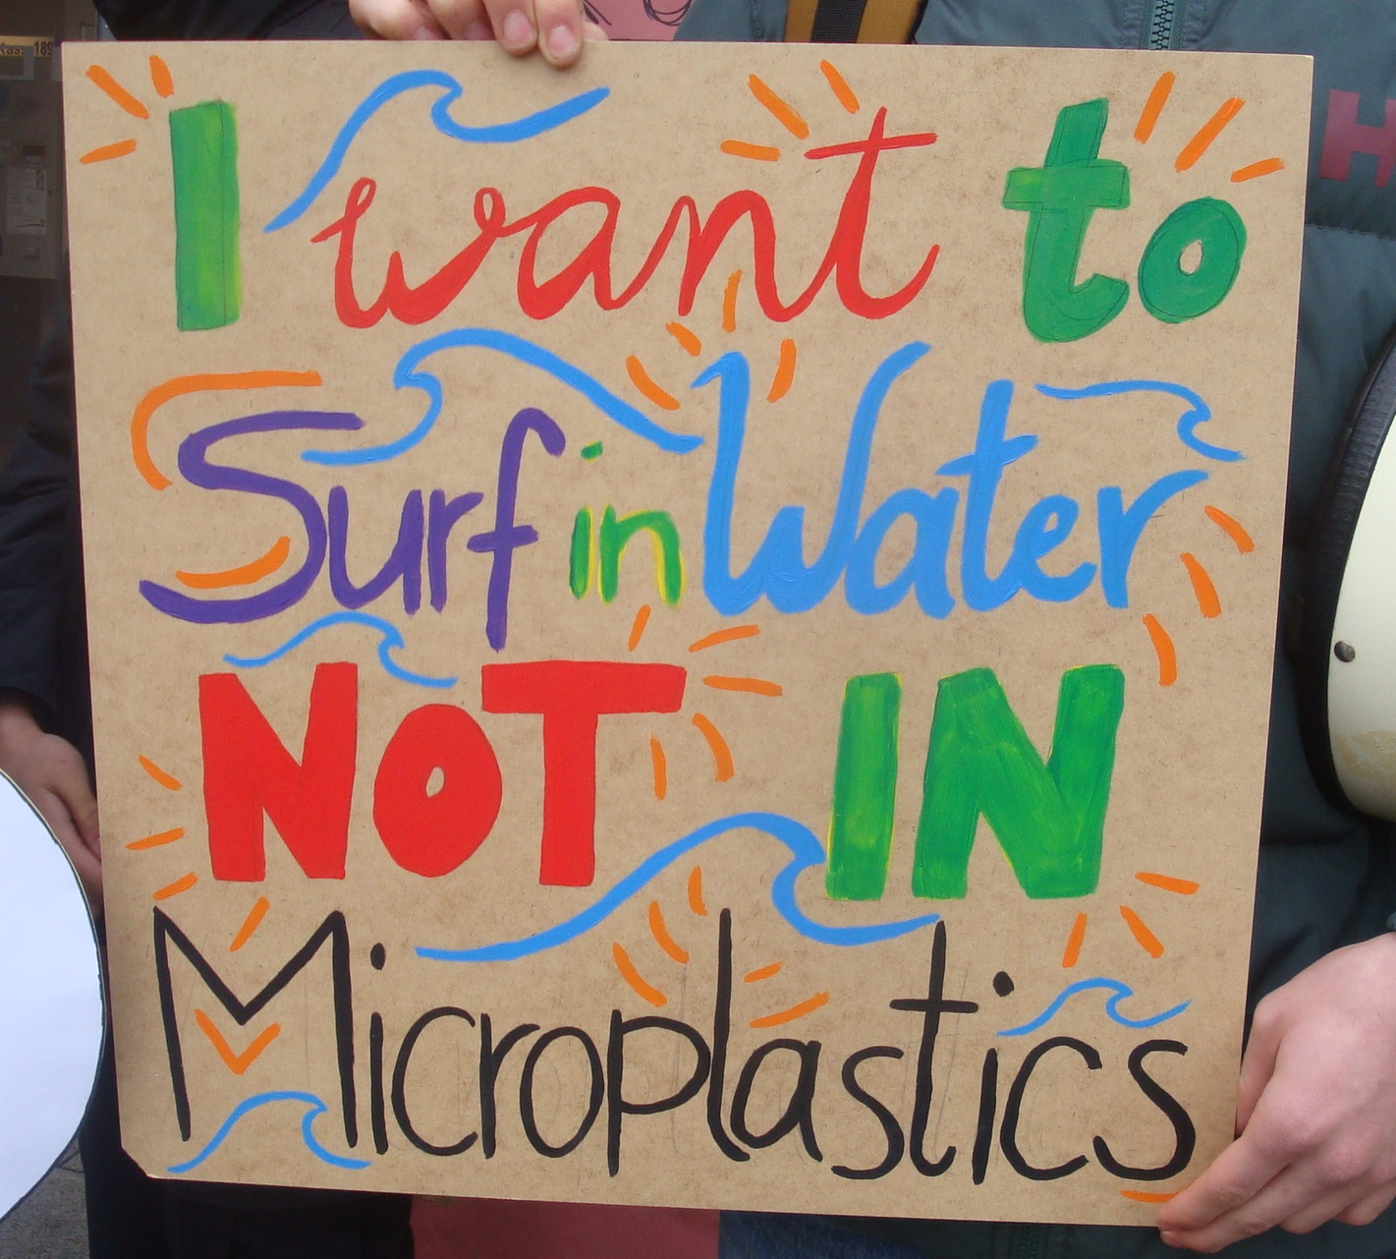

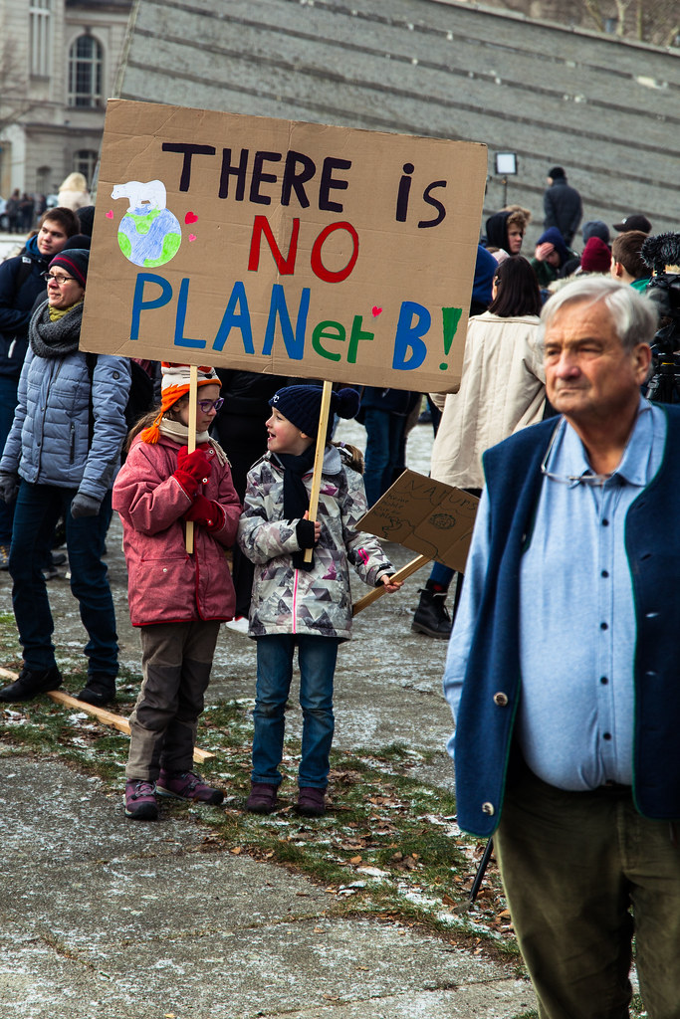

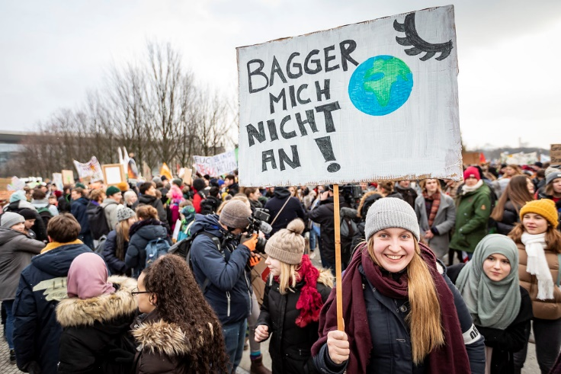

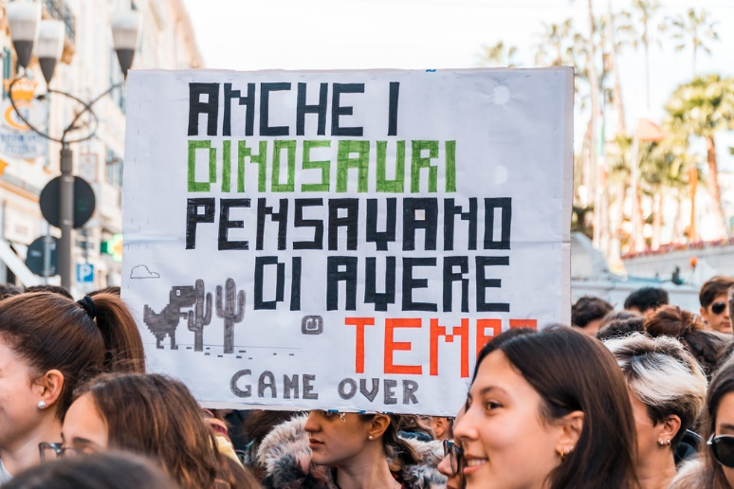

D. In pairs/groups ask your students to choose one of the following topics related to the environment and create two posters similar to the examples provided above. One poster should be in their first language or in a language they master well, while the other poster should be in a language (the majority of) the class is not fluent in, to encourage the learners to challenge their plurilingual repertories and possibly reach a wider audience with their composition of posters. Students can choose one of the topics in the following list or come up with other themes.

- Water pollution
- Overpopulation
- Overconsumption
- Reduction of meat and fish consumption
- Overfishing
- Waste sorting
- Deforestation
- Reduction of plastic and paper use
- Global warming
- Melting glaciers
- Pollution
- Loss of biodiversity/species extinction

Suggest that your students create the posters using the following tool available on the official webpage of the initiative “Friday for future”: https://fridaysforfuture.org/take-action/resources-and-materials/

E. Once the posters have been created, hang them up in the corridors of the school.

Activity 3: Biodiversity loss

Estimated time: 1h.

Learning objective:
- Raising students’ awareness of biodiversity and its importance for the planet and humanity.

Resources needed:
- Internet access.
- Board.
- Projector.
- Students’ personal computer or tablet/School computers.

Exercise 1: What is biodiversity?

A. Introduce the concept of “biodiversity” to your students by showing them the following video https://www.youtube.com/watch?v=b6Ua_zWDH6U released by WWF, which explains what “biodiversity” is and its importance for the survival of our planet and for all creatures living on it, including human beings.

B. Ask students to think about a couple of keywords related to the topic and then create a concept map on the blackboard as brainstorming activity. Your students might think of keywords such as “flora”, “fauna”, “different species”, “pollution”, “human activity”, “ecosystems”, “preservation”, etc.

Exercise 2: Species extinction

A. Divide the class into groups. Give each group Handout B and ask them to search the Internet for the following information regarding plant or animal species. Groups can choose whether to work on fauna or flora, but make sure that both are covered within the class.
- Which plant/animal species have become extinct? When?
- Which plant/animal species are in danger of extinction?
- Are there and endangered animals/plants close to where you live?
- What are the causes of these extinctions?
- What are the consequences of these extinctions for the life of the planet and human beings?
- What can be done to prevent the phenomenon of extinction?

B. Each group creates a power point to present their work to the other groups. The research and the power point creation (or at least part of it) could be set as group homework activities. Remind students to include graphs and images in the presentation to make it more impactful, interesting, and effective.

Activity 4: Pollution and waste management

Estimated time: 45 minutes.

Learning objectives:
- Making students aware of the different kinds of pollution, and encouraging them to reflect on their causes and consequences.
- Promoting the importance of separate waste collection and its correct use.

Resources needed:
- Internet access.
- Printout material/Projector.

Exercise 1: Let’s explore all types of pollution

A. Ask students to think of all the types of pollution they know. They might suggest some of the following kinds of pollution:
- Air pollution
- Water pollution
- Land pollution/contamination
- Light pollution
- Noise pollution
- Plastic pollution

B. Divide the students into pairs. Give them Handout C and ask each pair to start a debate about one of the following types of pollution:
- Air pollution
- Water pollution
- Plastic pollution
- Noise pollution
In each pair, partners are asked to take opposite sides of the discussion, thinking of arguments to defend their position and argue against their partner's point of view. If need be, this task or part of it may be set as homework.

Handout C proposes the following roleplay examples to the students, but they might have additional ideas:
- Air pollution: debate between a person who often takes public transport or cycles to reduce air pollution and a person who would never give up travelling by car.
- Water pollution: debate between the owners of a farm that uses chemicals, pesticides, and insecticides and an environmental association that campaigns against the use of such products.
- Plastic pollution: debate between the owner of a company producing plastic products (cups, straws, cutlery, etc.) and the owner of a company producing the same products but biodegradable or a consumer who buys only biodegradable products.
- Noise pollution: debate between the owner of a club that stays open until late at night and the owner of a flat in the immediate vicinity who complains about loud music and noise caused by the club's customers.

C. Now ask each pair to present or act their debate to the class.
Exercise 2: Sustainable waste management
A. In plenary, ask the class the following questions:
- Do you separate waste in your daily life (at home, at school, etc.)?
- Does your family separate waste at home?
- According to you, why is it important to separate waste?
- Are you sure you are separating your waste properly?

B. Explains to your students that often the guidelines for sorting waste properly can vary slightly depending on the city (and the country) where one lives. Ask students to download the waste separation guidelines from their municipality's website and compare them in class. Are there many differences? If so, what is different?

C. Now present the exercise in Handout D to the students (remind them not to use the Internet!).

To which waste class do the depicted objects on the handout belong? Choose from the following alternatives:
paper, glass, plastic, metal, organic, undifferentiated/mixed, e-waste, medicine containers

Most probable solutions (exact answers depend on the municipality):
- Can: plastic/glass/metal (it depends on guidelines)
- Pens: undifferentiated/mixed
- Batteries: e-waste
- Medicines: medicine containers
- Light bulb: e-waste
- Tea bag: organic
- Broken phone: e-waste
- Broken scissors: metal
- Broken glasses: glass

D. After correcting the exercise above, you could ask the students to create a poster for the class/school where they make it clearer how waste is generally classified and provide instructions to their peers and teachers.

E. If possible, you may want to complete this activity by organising a trip for your class. You could accompany your students to a public space (park, forest, riverbank, square, etc.), and ask them to collect and differentiate rubbish according to the local norms.

Activity 5: Overconsumption

Estimated time: 1h (in class) + 1 week (out-of-class task).

Learning objectives:
- Making students reflect on how aware they are of their consumption habits and how much these are influenced by psychological and economic mechanisms.
- Raising students' awareness of the importance of reducing waste and increasing recycling.

Resources needed:
- Internet access.
- Students’ personal computer or tablet/School computers.
- Projector.

Exercise 1: What is overconsumption?

A. To introduce the concept of “overconsumption” to your students, write on the board the brief definition provided by Merriam-Webster: “[Overconsumption is the] excessive consumption or use of something”. Give your students about 5-10 minutes to reflect on their own and their families’ consumption habits and ask each of them to take notes individually in their notebooks. Suggest that they think about clothes, shoes, home furnishing, electrical devices, etc. You could also suggest answering questions along these lines:
- How often do you buy an article of clothing or a pair of shoes?
- How many items of the same type of clothing do you have (e.g., how many pairs of shoes, trousers, coats, etc.)?
- How often do you redecorate/change the furniture in your room?
- How long have you had your current phone?
- What do you do with clothes, shoes, electronic devices, etc. you no longer use?

B. Then, ask your students to check and discuss their notes with the classmate sitting next to them. Do they have similar consumption habits?

C. Now in pairs/groups ask your students to consider which other aspects of overconsumption might be relevant. They might suggest the following: single-use plastic product, electronic waste, fossil fuels, electricity. Then ask them to reflect on the following questions:
- Which aspects of my consumption could be more sustainable?
- How could I reduce my consumption?

D. Using the board, gather all the ideas, opinions and proposals put forward by the class in previous tasks, and summarise/discuss them in plenary.

Exercise 2: Planned Obsolescence

A. Ask your students if they know or can guess what “Planned Obsolescence” means. Encourage them to make suggestions and start a brief class discussion.

B. Now show them this short video https://www.youtube.com/watch?v=voyLPXG-EJc which explains what Planned Obsolescence means and how it works.

C. First, make sure the students get the irony in this video. Then, ask them to answer the following questions in pairs or groups:
- Do you feel (or have you ever felt) the mechanism of “Psychological Obsolescence” around you?
- Have you ever thrown something away just because it was no longer fashionable or because a new version of the product had come out?
- Have you ever had to change an electronic device (television, smartphone, computer, etc.) after only a couple of years because it no longer worked?

D. Discuss with the whole class their answers to the previous questions. Make them reflect on the fact that we are all involved in these psychological and economic mechanisms but, if we start to buy more rationally and consciously (i.e., become more aware of how marketing strategies work to make us believe we need something we don’t, become more resilient in the face of peer-pressure, resist the temptation to buy things we don’t really need simply to impress others or because others have them, etc.), we can all together reduce overconsumption.

Exercise 3: How would you rate your consumption habits?

A. Split students into groups of 3 or 4 members. Ask each group to design a short survey about consumption habits to be administered to the other students in the school. The goal of this task is both in the design of the survey (as students must think of what questions are the most relevant to protect the environment) and in the following analysis of the collected answers.

For your convenience, here are some questions that could be included in the questionnaire. Remember not to give them to the students, as they should be encouraged to come up with their own ideas first. Ask each group to think of some questions and discuss them in plenary. To facilitate analysis, ask students to include only closed questions, preferably using a scale for each item (for example, they could create a scale with intervals from 0 to 10 or from 'never' to 'very often' according to the questions).

- How often do you buy an article of clothing?
- How often do you buy new shoes?
- How long have you had your current phone?
- How much of the food you buy end up in the bin?
- How many times a week do you consume animal products?
- How many times a week do you use public transport (train, bus, etc.) or an electric bike?
- How much plastic is consumed in a week by your household?

B. Each group reports their questions to the others. During the discussion in plenary, make sure that the class chooses a maximum of 8 questions to be included in the survey (this way all groups have the same survey to administer). Remind your students that the survey must be anonymous for privacy reasons.

C. Ask students to design the questionnaire, using a free online service to create web-based surveys, such as Google Forms or the free account of SurveyMonkey. Instructions for designing a survey can be found here:
- Google Forms: https://support.google.com/docs/answer/87809?hl=en.
- SurveyMonkey: http://www.wikihow.com/Create-an-Online-Survey-With-Surveymonkey.

D. Ask the class to invite the other students in the school, their friends and families to reply to the questionnaire. If your students do not have the emails of the other students (this could happen due to privacy reasons), you can send the survey to your colleagues asking them to instruct their students to fill in the questionnaire. Give your students a week to collect as much data as possible.

E. The online tools used to create the survey allow your students to obtain the results in the form of percentages and graphs. After discussing the results with the whole class, instruct your students to write a short report and share it with their families. This activity could be a good opportunity to create an educational link between school and families.

Exercise 4: How can we avoid the trap of overconsumption?

Set up with your students a place in the school (in the library, in the corridors, or in a common area) where students voluntarily put objects they no longer use and which are available to other students (books, school supplies, clothes, household items, toys, etc.).
In this “recycling area” your students could also hang up all the posters made in the previous activities.
This is an initiative that aims to make all students aware of the importance of reducing waste and to encourage them to recycle.

Activity 6: Sustainability

Estimated time: 1h.

Learning objectives:
- Making students reflect on what practices can be adopted to make the school a more sustainable environment.
- Making students aware of their ecological footprint, encouraging them to make their lifestyle more sustainable.

Resources needed:
- Internet access.
- Students’ personal computer or tablet/School computers.

Exercise 1: Sustainability at school

A. Split students into groups. Ask each group to create a list with some proposals to make the classroom and the school a more sustainable environment. Here are some proposals your students might think about: encouraging recycling, saving water, avoiding the use of plastic products in the canteen, serving only local products in the canteen, sorting waste, reducing the use of printouts, switching off the light in the classroom during break time if the room is empty, etc.
Remember not to give them to the students, as they should be encouraged to come up with their own ideas first.

B. Collect all ideas and proposals and discuss them in plenary. Then gather them into 3 or 4 macro-topics. For example: proposals to make the canteen a more sustainable environment, ways of saving resources, etc.

C. Now instruct students to create 3 or 4 posters illustrating the proposals for a more sustainable school environment. Remind students to include pictures and graphs in the posters. Then give them to the other students in the school, so that the lists are present in every class.

Exercise 2: What is your Ecological Footprint?

A. Ask students to take the following quiz offered by the Ecological Footprint Network, which calculates one’s personal ecological footprint: https://www.footprintcalculator.org/home/en. The Footprint Calculator requires information about food habits, living situation, energy use at home, waste habits and mobility. Tell students to gather this information from their parents if they are not sure about some of the answers.

B. After taking the quiz, start a brief class discussion and ask students to reflect on the following questions:
- Does your personal ecological footprint surprise you?
- How far is it from the average ecological footprint?
- On the basis of the results obtained and what you have learned through the previous activities, how would you change your habits?

C. Now ask your students to write individually on anonymous cards ONE change they will make as of today to reduce (even slightly) their ecological footprint and have a more sustainable lifestyle. Make sure they think of concrete actions – no matter how small these acts are, and that they understand they need to start acting today, not in some vague future. Ask them to pint their card on a board as a reminder of what they have committed to.

References:

Merriam-Webster. (n.d) Overconsumption. In Merriam-Webster.com dictionary. https://www.merriam-webster.com/dictionary/overconsumption

Page, E. (1999). Intergenerational justice and climate change. Political Studies, 47(1), 53-66.

Weston, B. H. (2007). Climate change and intergenerational justice: Foundational reflections. Vt. J. Envtl. L., 9, 375.

