The
Global Citizenship
and
Multilingual Competences
Toolkit

Teaching module

Disclaimer: The European Commission support for the production of this publication does not constitute an endorsement of the contents which reflects the views only of the authors, and the Commission cannot be held responsible for any use which may be made of the information contained therein.​

Unit 5:
Hunting for fake news through
critical reading

Teaching Module

Table of contents
Activity 1: Towards a definition of fake news p. 5
Activity 2: Analysis of the text and linguistic strategies p. 7
Activity 3: Let’s create fake news p. 10
Activity 4: How much do your peers know about fake news? p. 12

Unit 5: Focus on teaching

Hunting for fake news through critical reading

Introduction

This unit contains activities aimed at developing your students' independent thinking as well as critical attitudes and behaviours. The materials and exercises provided have been specifically designed to provide learners in secondary education (ages 13-18) with the tools needed to engage critically with the information spread by the mass media (newspapers, websites, social networks, etc.). In fact, the media which students use in their daily lives may disseminate fake news deliberately created to look very similar to real news. This phenomenon makes the development of critical thinking and reading very important, as it is not always easy to realise that what we are reading does not correspond to reality. In addition, you will find activities that give your students the opportunity to actively work with their languages, with the aim of raising their awareness of the importance of multilingualism as a learning resource. The target audience are 10- to 18-year-olds.

Learning objectives and outcomes

Learning objectives  This unit aims to: | Learning outcomes  At the end of the unit, your students can:
1. [Attitude, n. 9] Stimulate students to think critically about what they read in newspapers or on the Internet.  2. [Values, n. 9] Raise students’ awareness of the importance of developing critical attitudes and behaviours.  3. [Attitude, n. 8] Work actively with students’ linguistic resources. | 1. [Skills, n. 1] Use their critical and independent thinking when analysing what they read in newspapers or on the Internet.  2. [Skills, n. 2] Have the proper tools, strategies and resources to engage critically with mass media and become aware of its influence on people’s thinking and attitudes.  3. [Skills, n. 10] Understand how important it is from an educational point of view to use their different languages as resources.

Activities

Activity 1: Toward a definition of fake news

Estimated time: 45min.

Learning objectives:
- Make students reflect on how aware they are of fake news and of their typical features.
- Help students develop some skills and useful strategies to spot fake news.

Resources needed:
- Internet access.
- Projector/printout materials.
- Board.

Exercise 1: Starting from your students’ experience

A. To introduce your students to the concept of fake news, write on the board the following questions:
- Why do you think fake news items are created and disseminated?
- Have you ever read an article that turned out to include wrong information? If so, where did you find it? In what language was it written? What was the article about? What helped you realise it contained fake news rather than reliable information?
- Do you think you are aware of fake news? Why do you think so?

B. Ask students to reflect on the questions alone for 10 minutes and take notes on their answers in their notebooks. Then, ask them to compare their notes with the person sitting next to them. Did they have similar ideas?

Exercise 2: Hunting for a definition

A. Instruct your students to write on a sheet of paper a brief definition of fake news and to list some key words regarding this concept.

B. Collect all the sheets and start a brainstorming activity on the board. List all their ideas, key words and definitions with the aim of finding a fairly detailed definition shared by the whole class.

C. Now that the class has found a shared definition, give your students the following definition of fake news:

Fake news items are false or misleading stories and information designed to look like news, usually created to be widely shared or distributed for the purpose of generating revenue, promoting or damaging the reputation of a public figure, a political movement, a company, etc. The spread of fake news has increased with the rise of social media, especially Facebook. In fact, nowadays many people have access to news through social media and websites and it can be difficult to establish whether stories are true or not. Information overload and a general lack of understanding about how the Internet works has also contributed to an increase in fake news or hoaxes.

In fake news, the content can be misleading, manipulated or even completely false, thus deliberately designed to deceive and harm. Moreover, fake news often presents a false connection between the information provided and the context of the article: in these cases, the content is not supported by the headlines, visuals or captions.
The term “fake news” refers also to satirical articles which are characterised by the use of exaggerations and introduce non-factual elements that are primarily intended to amuse, but also have the potential to fool.

D. Provide your learners with enough time to read and analyse the definition. Then ask them to compare the definition created by the class with the given one. Ask them to answer the following question:
- Which characteristics of fake news that are listed in the given definition are missing in the one created by the class, and vice versa?

Exercise 3: Survival skills against fake news

A. Open this link (https://www.mindtools.com/pages/article/fake-news.htm) on the class computer and project it on the screen. If this is not possible, send the link to the students and ask them to individually explore the website (on their personal computer or tablet) or share the printouts of the webpage.

B. Divide the students in pairs. After they have read the webpage carefully, ask each pair to rank the tips in the article from the most to the least important/useful (see Handout A).

C. Debrief by asking each pair to introduce their own rankings. While you (or a student) take notes on the class board, the entire class progressively reaches an agreement on what will, in the end, become the class ranking. The class ranking may be integrated into a poster so that it can be permanently displayed in the classroom.

D. Still in plenary, ask the students:
- Which of these six tips did you already know and use to detect fake news?
- Can you think of any other useful tips to add to the list?

Activity 2: Analysis of the text and linguistic strategies

Estimated time: 45min.

Learning objective:
- Help your students develop a critical attitude towards the text by:
- Questioning the content of the article.
- Analysing the persuasive tactics and linguistic strategies employed.

Resources needed:
- Internet access.
- Printouts.
- Students’ personal computer or tablet/School computers.
- Board.

Exercise 1: A fake news item regarding NASA

A. Provide the students with the following article which is a piece of fake news (see Handout B). Remember not to tell students this is fake news! Instruct them to read it carefully.

7 days of total darkness announced by NASA

NASA has announced that the Earth will go through a period of 7 days of total darkness at the end of 2026, most probably in the second half of October. This astronomical event involving Venus and Jupiter is extremely rare, and it last happened half a million years ago.

Charles Bolden, who was recently appointed to head of NASA by President Biden, issued a 2000-page report explaining this rare event to the White House.

The report explains that Venus and Jupiter will engage in a close parallelism involving only a 1-degree separation. This will cause Venus to shine 1000 times brighter than Jupiter. The light from Venus will heat up the gases on Jupiter, causing a reaction and releasing an unprecedented amount of Hydrogen into Space. This Hydrogen gas will make contact with Earth’s sun, causing a massive explosion on the Sun’s surface, raising its temperature by 9,000 degrees Kelvin in an instant. The heat will cause the Sun to dim to a bluish colour, which will be perceived as night time on Earth, similar to the light of the Moon. This phenomenon will last for 7 days, with the Sun soon recovering its normal state quite rapidly, in about 4 minutes.

B. Divide students into groups and ask each group to do one of the following activities (computer and internet access required). Each group has to find at least three sources related to the information they are looking for:
- Search the internet for the news announced by NASA. Was the news on the NASA website or other official websites?
- Verify who Charles Bolden is.
- Search for information about the described astronomical event.

Provide the learners with enough time to read and analyse the sources, possibly even as part of their homework. While assigning the task, specify that each group will be required to report their findings to the class.

C. Ask each group to share the information retrieved with the other groups. Groups working on the same task will compare their results (the websites they visited) and strategies (how they organised the work).

D. Create a diagram on the board (you could ask a student to do this) with the information found by each group. Make sure that, during the process, the students come to understand that the news announced by NASA is fake and have an awareness of the strategies they and their peers used to reach this understanding.

Exercise 2: Let’s take a closer look at the news

A. Put your students in pairs or groups, ask them to read the NASA article and give them Handout C. Ask them to complete the checklist provided and double-check their previous analysis. Make it clear that they should focus mainly on the linguistic strategies and persuasive tactics used in the fake news. If needed, provide some guidance; for example, tell them that they can focus on any 'sensationalistic' language or on the sources of information mentioned.

B. While they are doing the task, write on the board the checklist items, which are the following:

- The article is enjoyable
- The language leaves no room for uncertainty
- The article has an impressive headline
- The article is well written
- The article is full of rhetorical language
- The article contains inaccurate or completely false information about events or persons mentioned
- In the article there are a lot of stereotypes
- The content of the article is presented in a categorical way
- The article is divided into several paragraphs
- In the article there are phrases that include exaggerated language
- The author uses specialist or technical language in the article
- The content of the article is not purely informative but has a negative (or positive) connotation in order to emotionally engage the reader

C. Lead a class discussion, during which each pair/group explains their own answers. During the discussion, help students reach an understanding that the most suitable answers in this case are n. 2, 3, 6, 8, 10, 12. However, explain that, in other cases, people writing and sharing fake news strategically adopt other strategies; e.g., they might imitate specialist/technical language (N. 11) to convey the idea of professionalism, or make the text particularly enjoyable (N. 1) to distract the reader and/or make the contents easier to memorise.

Activity 3: Let’s create fake news!

Estimated time: 1h.

Learning objectives:
- Get students to better understand what elements characterise fake news and
how it is created.
- Make students aware of the persuasive tactics and linguistic strategies employed
in fake news in order to give them the proper tools to spot it.
- Raise your learners’ awareness of the value of their different languages as learning resources.

Resources needed:
- Internet access.
- Projector/printout material.
- Board.
- Students' personal computer or tablet (if possible).

Exercise 1: How to make fake news

A. Open this link https://gijn.org/six-fake-news-techniques-and-simple-tools-to-vet-them/ on the school computer and project onto the board. If this is not possible, send the link to the students and ask them to individually explore the website (on their personal computer or tablet) or share the printouts of the webpage.

B. Ask the students to read all steps carefully. After reading the webpage, you can ask one or more students to summarise the main information.

Exercise 2: Try your hand at it!

A. Divide the students in pairs or groups and ask them to write their own fake news about a topic of their interest, following the advice and steps listed on the webpage. Remind them to be as credible and convincing as possible! Encourage them to create their “Breaking news” banner using a meme generator, for example the Breaking News Meme Generator: https://breakyourownnews.com/. If they don’t have a personal computer or tablet in class, ask them to do this activity at home. Of course, make sure they don't publish it outside of this context!

B. Instruct each pair/group to send their work to you. During the next lesson, project all the fake news written by the students (alternatively, you could print out the fake news on big sheets of paper and hang them all on the wall) and conduct a poll to find out which article is the most convincing and the most similar to real news. Ask your students to give a score from 1 to 10 for each article and instruct them to justify the given score, based on the typical features of fake news analysed in the previous activities.

C. Award a 'prize' to the group that wrote the best article. Then discuss in plenary what features made the winning article better than the others.

Exercise 3: Fake news and multilingual competence

A. In pairs/groups, ask your students to write a fake news item in a foreign language they master (you could also ask them to translate the article they have already written for Exercise 2). If need be, this task could be set as homework. Make sure that each pair/group send their work to you in advance.

B. Select some of the texts written by the students. Choose those written in languages that the whole class can at least partly understand.

C. When back in class, draw your students' attention to the persuasive tactics and linguistic strategies they used in the texts selected and ask them to answer the following questions:
- What are the main strategies used to make fake news credible?
- Do these tactics and strategies differ depending on the language of the text? If so, how? If not, what aspects and elements do they have in common?

D. Ask your students to reflect on the difference between the article written in their first language and the one written in a foreign language. Ask them the following questions and discuss in plenary:
- Did you use different linguistic strategies and persuasive tactics to write the articles?
- Did you use different sources to write the articles?
- Did you use approximately the same number of sources to write the articles? If so, how many did you use? If not, for which of the two articles did you look for more information?

Activity 4: How much do your peers know about fake news?

Estimated time: 1h 30min (in class) + 1 week (out-of-class task)

Learning objectives:
- To make students aware of how informed their peers are about fake news.
- To allow students to explore the phenomenon of fake news by collecting ideas,
data and testimonies from their peers.
- To allow students to compare their level of awareness of the fake news phenomenon with that of their peers interviewed.
- Provide students with tools and strategies to schematise the information they
learn in order to analyse and memorise it more easily.

Resources needed:
- Internet access.
- Students’ personal computer or tablet/School computers.
- Projector.

Exercise 1: Let’s create a survey!

A. Split students into groups of 3 or 4. Ask each group to design a short survey to be administered to the other students of the school about how much they know about fake news. The goal of this task is both in the design of the survey and in the students’ analysis of the collected answers.

Here are three questions that can be included in the questionnaire. Remember not to give these questions to the students, as they are just suggestions, and the students should be encouraged to come up with their own ideas first. Ask each group to think of some questions and discuss them in plenary. To facilitate analysis, ask students to include only closed questions.

1. What are the typical features of fake news? Choose a maximum of 3 of the following options:
a) The article is enjoyable
b) In the article there are phrases that include exaggerated language
c) The article is well written
d) The content of the article is presented in a categorical way
e) The article contains inaccurate or completely false information about events or persons mentioned
f) There are a lot of stereotypes in the article

2. Have you ever read an article that turned out to be fake news?
a) I read articles that contain fake news every day on the Internet
b) I have read some articles that turned out to be fake news
c) I’ve never read an article that turned out to be fake news

3. Who do you see as responsible for stopping the spread of fake news? Choose a maximum of 2 of the following options:
a) journalists
b) national authorities
c) the press
d) citizens themselves
e) online social networks
f) EU institutions

B. During the discussion in plenary, choose with your students a maximum of 10 questions to be included in the survey (this way all groups have the same survey to administer). Make sure to remind your students that the survey must remain totally anonymous for privacy reasons.

C. Ask students to design the questionnaire, using a free online service to create web-based surveys, such as Google Forms or the free account of SurveyMonkey. Instructions for designing a survey can be found here:
- Google Forms: https://support.google.com/docs/answer/87809?hl=en.
- SurveyMonkey: http://www.wikihow.com/Create-an-Online-Survey-With-Surveymonkey.

D. Ask the class to submit the questionnaire to the other students in the school and to their friends. If your students do not have the emails of the other students (this could happen due to privacy reasons), you can send the survey to your colleagues asking them to instruct their students to fill in the questionnaire. Give your students a week to collect as much data as possible.

E. The online tools used to create the survey allow your students to obtain the results in the form of percentages and graphs. Share the results with the whole class and ask students (in groups/pairs) to write a report (in their first language or in a second language they master) on the data obtained. In this way, students can practise their expository writing.

Exercise 2: Let’s create infographics for the school!

A. After discussing the results of their survey with the whole class, ask each group to create an infographic which illustrates the data collected. Remind students that the infographic is designed for the school, so it must be multilingual in order to be easily understood by all students. Instructions for creating an infographic can be found here: https://www.canva.com

B. Ask each group to create a draft of the infographic.

C. Once they have shown you their own model, discuss their draft in plenary and give them general feedback. You can also provide your students with some examples available online and instruct them to search for other infographics similar to the examples provided (if need be, this last task could be set as homework).

Here are a few infographics to show as examples:

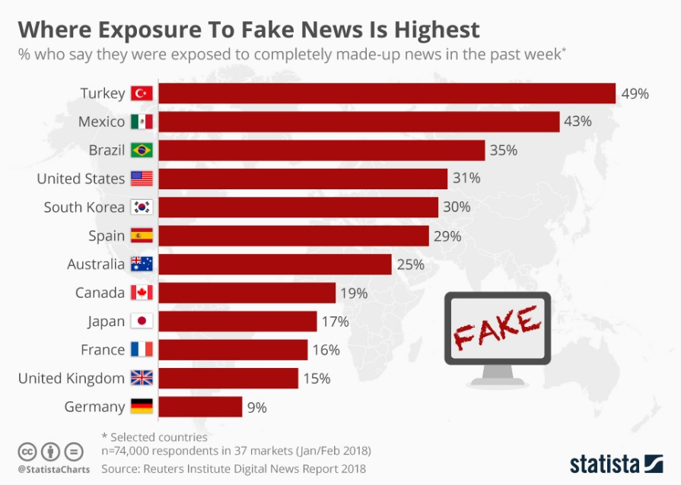

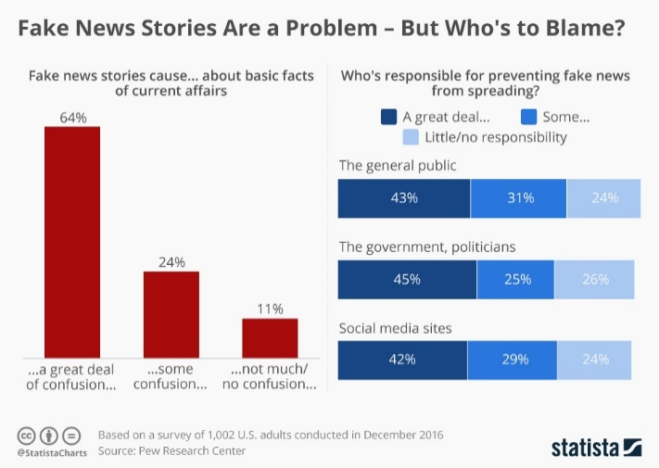

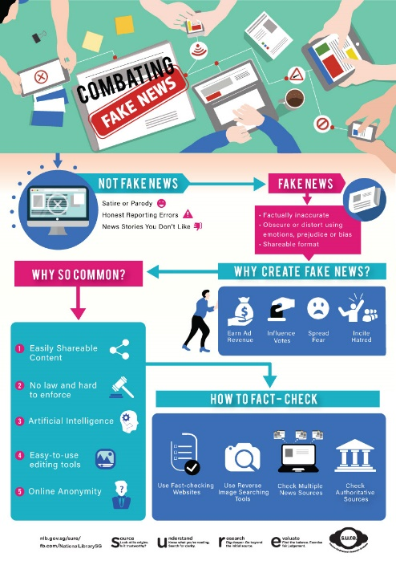

D. Ask the groups to modify their own infographic according to the feedback received and the examples provided.

E. When all the infographics have been created, print them out in colour and hang them in the corridors of the school so that they can be seen, read and analysed by all students!

Additional external resources

MediaSmart: Education from the Advertising Industry. (2021). Retrieved February 1, 2022 from https://mediasmart.uk.com/secondary-resources/#

McCandless, D. (2022). Information is beautiful. Retrieved February 1, 2022 from https://informationisbeautiful.net/visualizations/biggest-fake-news-of-2017/

