The
Global Citizenship
and
Multilingual Competences
Toolkit

Teaching module

Disclaimer: The European Commission support for the production of this publication does not constitute an endorsement of the contents which reflects the views only of the authors, and the Commission cannot be held responsible for any use which may be made of the information contained therein.​

Unit 1:
Connecting local and global issues

Handouts

Table of contents

Handout A: Multilingual peers: Find someone who p. 4
Handout B: Following my food and clothes around the world p. 5
Handout C: Privileges among us p. 7
Handout D: Tackling global issues p. 8
Handout E: Stereotypes in movies p. 9
Handout F: Stereotype scavenger hunt p. 10
Handout G: Language fun facts p. 11

Handout A:

Multilingual peers: Find someone who

Please think about the language(s) you speak, understand, or know some words in. Then, walk around and talk to your classmates. Find someone who speaks the same language(s) or different language(s) and share your knowledge with each other.

Same Language(s)

Different Language(s)

New words you learned

Handout B:
Following my food and clothes around the world
Do you know where your own food or clothes come from?
Indicate the countries you found on your products’ labels on the map below.

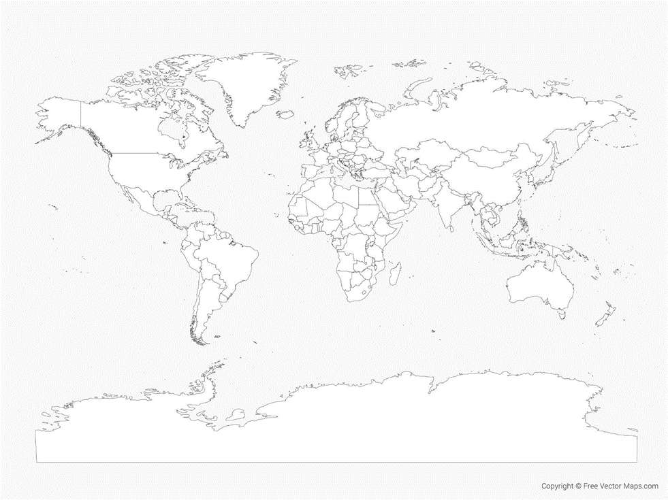Source: https://freevectormaps.com/world-maps/WRLD-EPS-01-0017?ref=atr

Discussion questions:
- Which continents are most prominently represented?
- Which one is mentioned most often?
- Are there any missing countries, and if so, why? (reflect beyond the list)
- How do you think the items have reached your country?
- Why do you think items such as clothes and food are imported?
- Thinking of your and your peers’ presentations, what have you discovered about the products imported and produced in your country?
- Do you know if similar products are being made locally, in your country? If so, which ones and where can these be bought?

Write your answers below:

___________________________________________________________________________
___________________________________________________________________________
___________________________________________________________________________

___________________________________________________________________________
___________________________________________________________________________
___________________________________________________________________________
___________________________________________________________________________
___________________________________________________________________________
___________________________________________________________________________

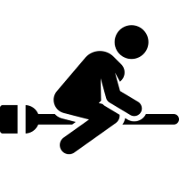
Handout C:
Privileges among us

What kinds of advantages in life do you think you may have which give you more benefits or opportunity (more privilege compared to others)? Have you seen it around you?

Types of privileges | Have I noticed this privilege in my surrounding? (explain your answer)
1.
2.
3.
4.
5.
6.
7.
8.
9.
10.

Handout D:
Tackling global issues

Please fill in the form of what global problems we have at the moment and what possible concrete actions you can suggest to help alleviate these problems.

Global problems | Potential concrete actions
1.
2.
3.
4.
5.
6.
7.
8.
9.
10.

Handout E:
Stereotypes in movies

Please complete the mind map below about your favourite movies. Write down your favourite movies and the names of the main characters.

Our favourite movies

Choose one movie that you would like to work on for the next activity. Then complete the table about the main characters’ age, gender, and ethnicity.

Name of the movie:
Main characters | Age | Gender | Ethnicity | Language

Imagine that the main characters are replaced by characters of a different age, gender, ethnicity or speaking a different language. How would that change the movie? Discuss your thoughts with your group.

Handout F:
Stereotype scavenger hunt

Welcome to the stereotype scavenger hunt!
During this scavenger hunt, you will have a closer look at your course book and will have the chance to figure out if your course book includes any stereotypical activities. Please share the name of your course book and always note down the page number on which you found the activities.
Look for activities in which the following people are depicted in non-stereotypical ways.

Name of your course book and subject: __________________________________________

Find an activity in which … is depicted in a non-stereotypical way. | Page number
girls or women
boys or men
a homosexual couple
a family with multiple ethnic backgrounds
a single-parent family
a disabled person
an elderly person
people speaking different languages

Handout G:
Language fun facts

Please read the following language fun facts and tick true or false.
Language fun facts | True | False
There are languages spoken by less than ten speakers.
Over 800 languages are spoken in Papua New Guinea, an island north of Australia.
Over 400 languages are spoken in the USA.
The Cambodian language has the longest alphabet with more than 70 characters.
30 of the world’s languages are spoken by half of the population of the world.
In Nigeria, more people are able to speak English than in the UK.
There are over 200 fake languages that were made up for movies or books, such as for Star Trek, Game of Thrones or Avatar.
About a third of the world is multilingual and therefore speaks more than one language.
English dominates the Internet and 70% of the information stored on computers is in English.
Hawaiians have over 200 different words related to ‘rain’.
20% of the English words are derived from French words.
Spanish is the official language in 20 countries.

