The
Global Citizenship
and
Multilingual Competences
Toolkit

Teaching module

Disclaimer: The European Commission support for the production of this publication does not constitute an endorsement of the contents which reflects the views only of the authors, and the Commission cannot be held responsible for any use which may be made of the information contained therein.​

Unit 2:
Promoting Ecoliteracy

Handouts

Table of contents
Handout A: The turning point p. 4
Handout B: Endangered flora and fauna p. 5
Handout C: Roleplay p. 6
Handout D: Where does this go? P. 7

Handout A

'The turning point'

With your partner, think of the video ‘The turning point’. If needed, you can watch it again here: https://www.youtube.com/watch?v=p7LDk4D3Q3U&list=PLLT1OZe-agIiakhDaKeq3z-FT6c9c9XDI

Which of the following environmental issues are covered in the animation? More than one answer is possible.

- 1. Water pollution
- 2. Overpopulation
- 3. Overconsumption
- 4. Reduction of meat and fish consumption
- 5. Overfishing
- 6. Waste disposal
- 7. Deforestation
- 8. Reduction of plastic and paper use
- 9. Global warming
- 10. Melting glaciers
- 11. Local support
- 12. Pollution
- 13. Acid rain
- 14. Loss of biodiversity/species extinction
- 15. Renewable energy

Handout B

Endangered flora and fauna

As a group, search the Internet for the following information. Please, consider that you will then be asked to create a presentation to share your research work with the class.

Decide whether you want to focus on animals or plants!

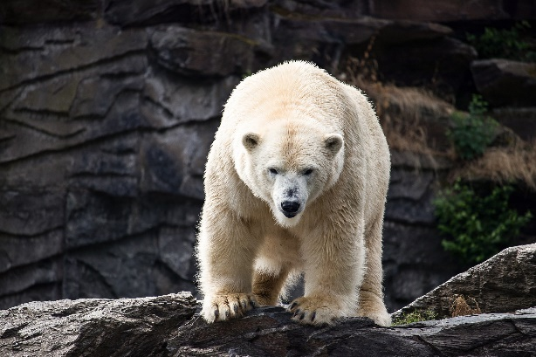

1. Which plant/animal species have become extinct?

2. Which plant/animal species are in danger of extinction?

3. Are there and endangered animals/plants close to where you live?

4.What are the causes of these extinctions?

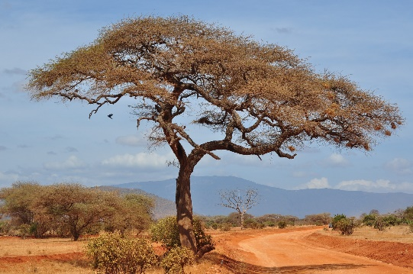
5. What are the consequences of these extinctions for the life of the planet and of human beings?

6. What can be done to prevent the phenomenon of extinction?

Handout C

Roleplay
As a pair, choose one type of pollution and the related scenario.

Discuss the topic with your partner, making sure that the two of you assume different sides (for example, in Scenario 1, one of you will defend the use of cars, while the other the importance of taking public transport).

When discussing with your partner, think of as many arguments as possible to defend your own position and to oppose your partner’s point of view. Tips: take notes, be clear… and polite!

Please, consider that you and your partner will then be asked to act out your debate in front of the class.
SCENARIO 2: Water pollution

Debate between the owners of a farm that uses chemicals and pesticides, and an environmental association that campaigns against the use of such products.
SCENARIO 1: Air pollution

Debate between a person who often takes public transport or cycles to reduce air pollution and a person who would never give up travelling by car.

SCENARIO 4: Noise pollution

Debate between the owner of a club that stays open until late at night and the owner of a flat in the immediate vicinity who complains about the loud music and noise caused by the club's customers.
SCENARIO 3: Plastic pollution

Debate between the owner of a company producing plastic products (plates, straws, forks, etc.) and the owner of a company producing the same products but biodegradable or a consumer who buys only biodegradable products.

Handout D

Where does this go?
To which waste class do the depicted objects belong? Match the following pictures with the appropriate waste container at the bottom of the page.

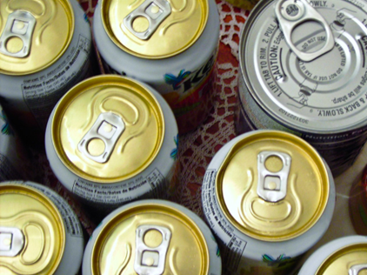

 | 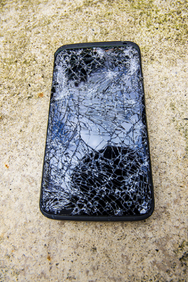 | 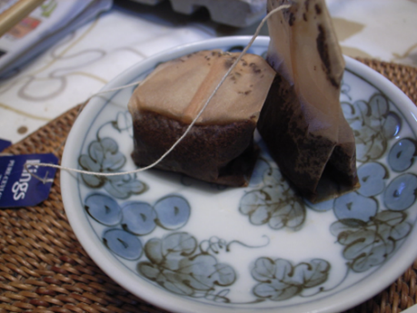
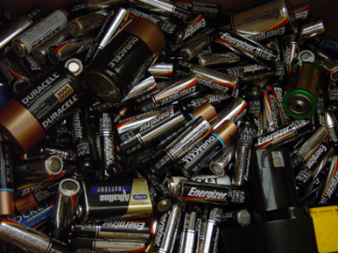 | 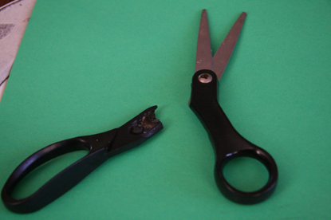
Paper | Plastic | Organic
Glass | Metal | Undifferentiated/  mixed
E-waste | Medicine  containers | Must be taken to a recycling centre

